# Linux Installation

Image: CentOS 6.4 Minimal

<http://vault.centos.org/6.4/isos/x86_64/CentOS-6.4-x86_64-minimal.iso>

Configuration of the VM should be as follows:

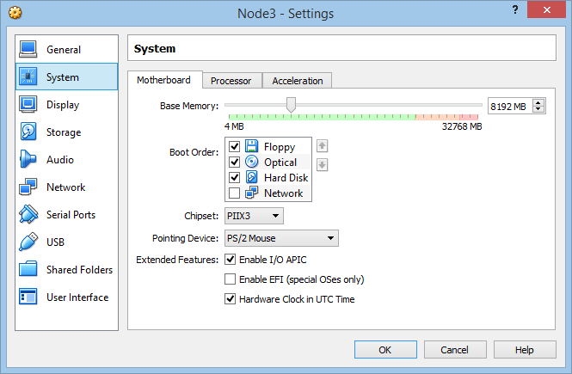

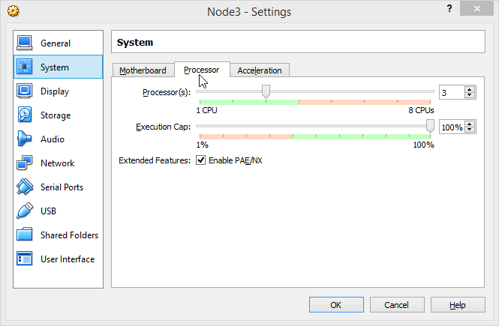

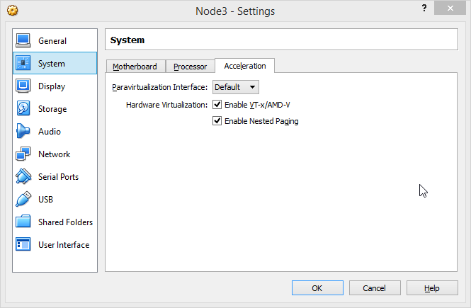

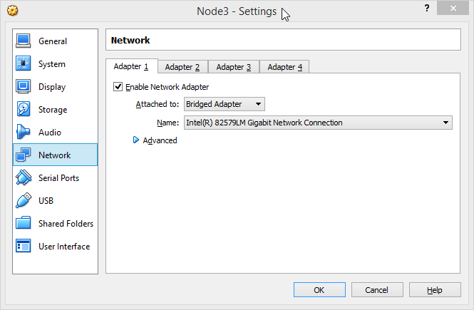

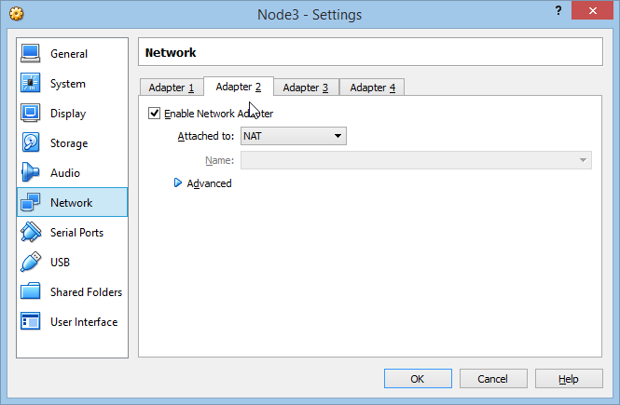

Just after the installation enable the network first:

Edit the file

vi /etc/sysconfig/network-scripts/ifcfg-eth0

press I for interactive mode

change the line ONBOOT=yes

press Esc

enter :wq

Do the same for

vi /etc/sysconfig/network-scripts/ifcfg-eth1

reboot

After reboot the machine will be able to access the internet. Check by

Ping google.com

For convenience

yum install nano

yum install mc

# Provisioning

Run the my_node_install.bash script which will install all necessary things -

# Putting the key

On the cloudera machine run the

ssh-copy-id [root@node3.cloudera](mailto:root@node3.cloudera)

then try to log on there.

# Add node

screenshots

# Apply Template

screenshots

# Template creation:

Как выглядит создание темплейта датаноды на главной машине